SOUTH DAKOTA CASA GRANT APPLICATION – ADDITIONAL FUNDING
Funding Request For:
___ New Program Development *
___ Expansion of Existing Program **
___ Marketing**

* Applications accepted on an ongoing basis
** Applications are accepted until November 30, 2022, for the calendar year 2023 and until April 30, 2023, for the calendar year 2024.

Purpose for CASA grant funds:
To support reasonable expenses for the development, growth, and continuation of CASA programs in South Dakota, per SDCL 16-2-51.

Eligible Recipients:
Eligible entities within South Dakota are:
- Recognized by the National CASA Association
- Administer a local/tribal CASA program
- Administer the SD CASA Association

Matching Requirements:
None

Funding:
The South Dakota CASA Commissioners thoroughly review each grant application and attachments for proposal appropriateness, financial need, and sustainability. The award recipient is responsible for meeting the administrative, financial and programmatic reporting requirements.
The Commissioners reserves the right to deny funding to a CASA program not meeting the grant application requirements.

Requirements and Attachments:
- Completed signed/dated grant application
- Proof of National CASA membership/provisional membership for new developing programs
- Detailed operating budget

- GRANT AND ATTACHMENTS MUST BE IN PORTRAIT FORMAT

CASA GRANT APPLICATION FORM

Amount Requesting:

Name of Program:

Executive Director:

Address:

Phone:

Email:

Website:

Service Area (counties, circuit)

Federal Tax ID #:

Board Chairperson Name and Address:

Board Treasurer Name and Address:

- Describe your proposal. Please include a project matrix with the seven categories listed below in the sample matrix.

- See sample project matrix below (attach matrix to application)

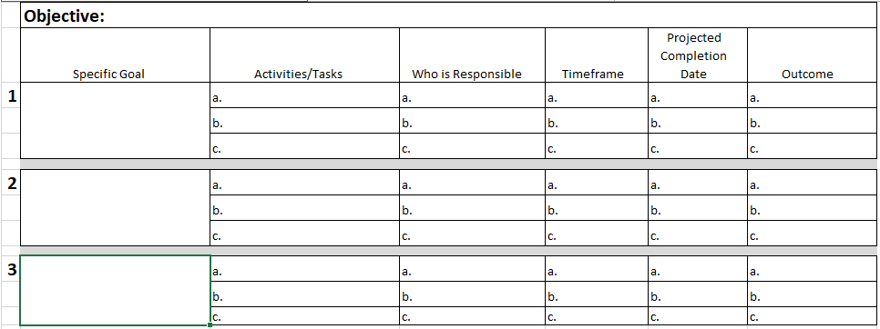

- Attach the budget for the grant project.

By signing below, I understand that the money requested must be used for the support, development, growth, quality, and continuation of the CASA program.

__________________________________ ___________________________________
Executive Director Date Board Chair Date

